Functional design Taludlaag Tool (DAMSlopeLayerTool)
Make a new tool like Dam Soil Profile Tool

Goal: Combination of surface line with a 2D soilprofile with a slope layer
The user can define an extra soil layer between the characteristic points Dike crest at river and Dike toe at polder with:
- thickness of layer [m], see slope_layer_thickness in OverviewDataUIAndEngine.xlsx
- material of layer; see slope_layer_material in OverviewDataUIAndEngine.xlsx
The bottom level of the extra layer is a copy of the surfaceline with an offset between points Dike crest at polder and Dike toe at polder. The offset is defined by the thickness of the layer.
The layer will be ‘filled’ with given material; parameter slope_layer_material
Both new parameters can be defined per location.

Figure 1 Profile with characteristic points
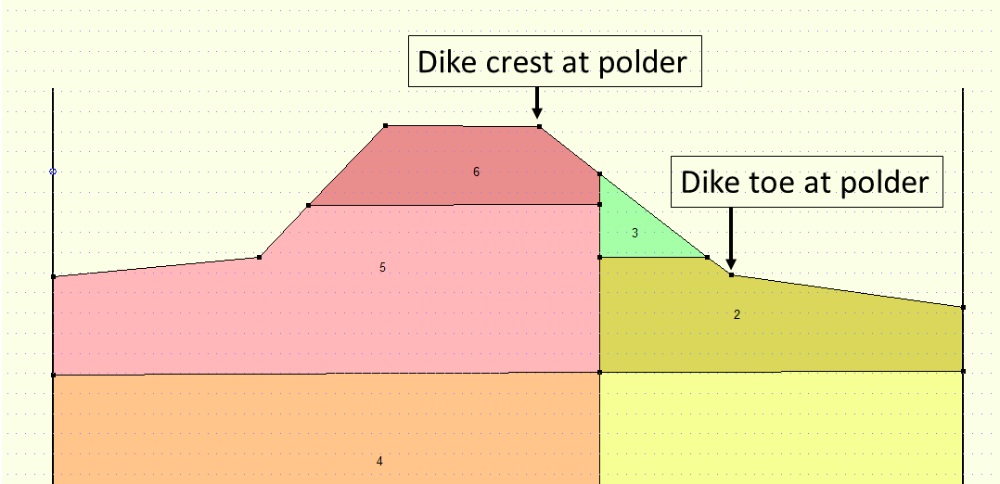
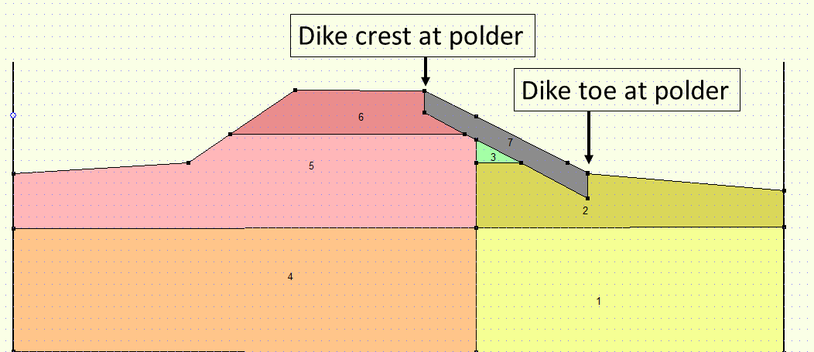
Figure 2 Profile with slope layer, defined by slope_layer_thickness (red arrow)

User Interface
No UI, but a command line tool

Usage:
AddLayerOnSlope -i <Input folder> -g <geometries folder> -o <output folder>
Usage:
- <input folder> is folder containing import files
- <geometries folder> is folder containing geometry files
- <output folder> is folder generated files

The import files will be read from the specified input location and the generated files (*.sti) will be written to the specified output location. The results will always be a set of 2d geometries (*.sti).

Import Files
These are the files needed for the import.
1. slopelayers.csv (for location properties) (different from normal DAM import, hence it’s a reduced version of the location.csv as used in DAM)
- locationId: string
- surfaceline_id: string
- soilgeometry2D_name: string (for2D), output of ‘Onder-naast Tool’/DamSoilProfileTool
- x_offset
- slope_layer_thickness: float
- slope_layer_material: string
- ophoogmateriaal: string.
Of all these items, only x_offset is optional (with a default value of 0). All other fields are required.
2. characteristicpoints.csv (same as normal DAM import)
3. surfacelines.csv (same as normal DAM import)

New parameters
Four new parameters are introduced in the new locations.csv version called slopelayers.csv:
 | Thickness slope layer | Material slope layer | Soilgeometry2D_  name | X_Offset
Name (in defx) | slope_layer_  thickness | slope_layer_  material | soilgeometry2D_  name | x_offset
Column csv /  attribute shape | slope_layer_  thickness | slope_layer_  material | soilgeometry2D_  name | x_offset
Type | Float | StringId | StringId | Float
Unit | [m] | [-] | [-] | [m]
Default | 0 | none | none | 0
Min value | 0 | none | none | none
Max value | 5 | none | none | none

The definition of x-offset is as shown in the figure below:
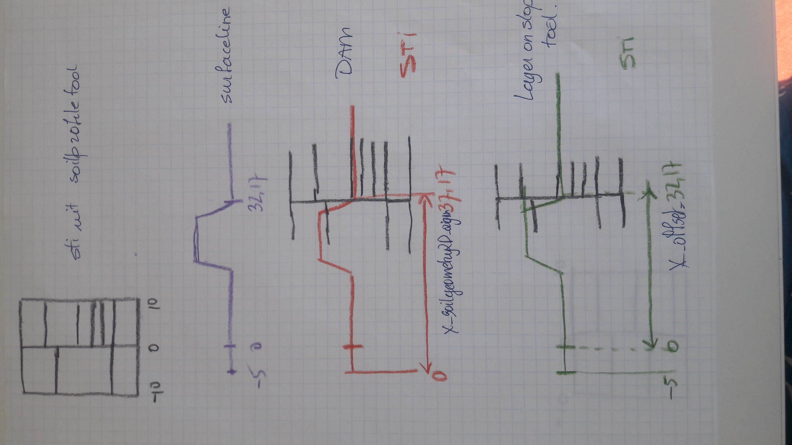

Error messages
All messages are provided in English language.

