Test Document D-SoilModel

Auteur: Daan van de Ven/ aanpassingen: Irene van der Zwan
Versie: 1.1
Datum: 08-09-2015
Gebaseerd op: D-Soil Model BETA 15.1.1



© Delft 2015 Deltares Systems
Inleiding

Algemeen

Dit document beschrijft de test procedure van het programma DSoilModel. De tester zal aan de hand van dit document een test uitvoeren. De test die beschreven wordt in dit document is een functionele test.
Testdata can be found:
Manual can be found:

Revisie historie

Versie 0.1 13-03-2014 Reinout de Jongh
Versie 1.0 03-11-2014 14.1.1.2 Daan van de Ven
Versie 1.1 08-09-2015 15.1.1. Irene van der Zwan
Algemene gegevens

Versie
Naam tester
Datum
 | Platform | Decimal seperation | Resolutie | Kleurenschema
Image
Taal Operating system | Nederlands  Engels
Kleurenschema | Zoals ingesteld  Anders, nl. …………………
Printers | Lokale printer (Agfa)  Netwerk printer (pr4oce)  …………………………  …………………………
Opmerkingen tester

V | General - Menu
Can you select something under the following options?
File
Edit
View
Tools
Help

 | General - Map
Do the following buttons work:
Zoom to extents
Zoom to data
Zoom to selected data
Zoom rectangle
Show legend
Open layer from file
Export Layers
Save map
Select web layer

Check:
Layout

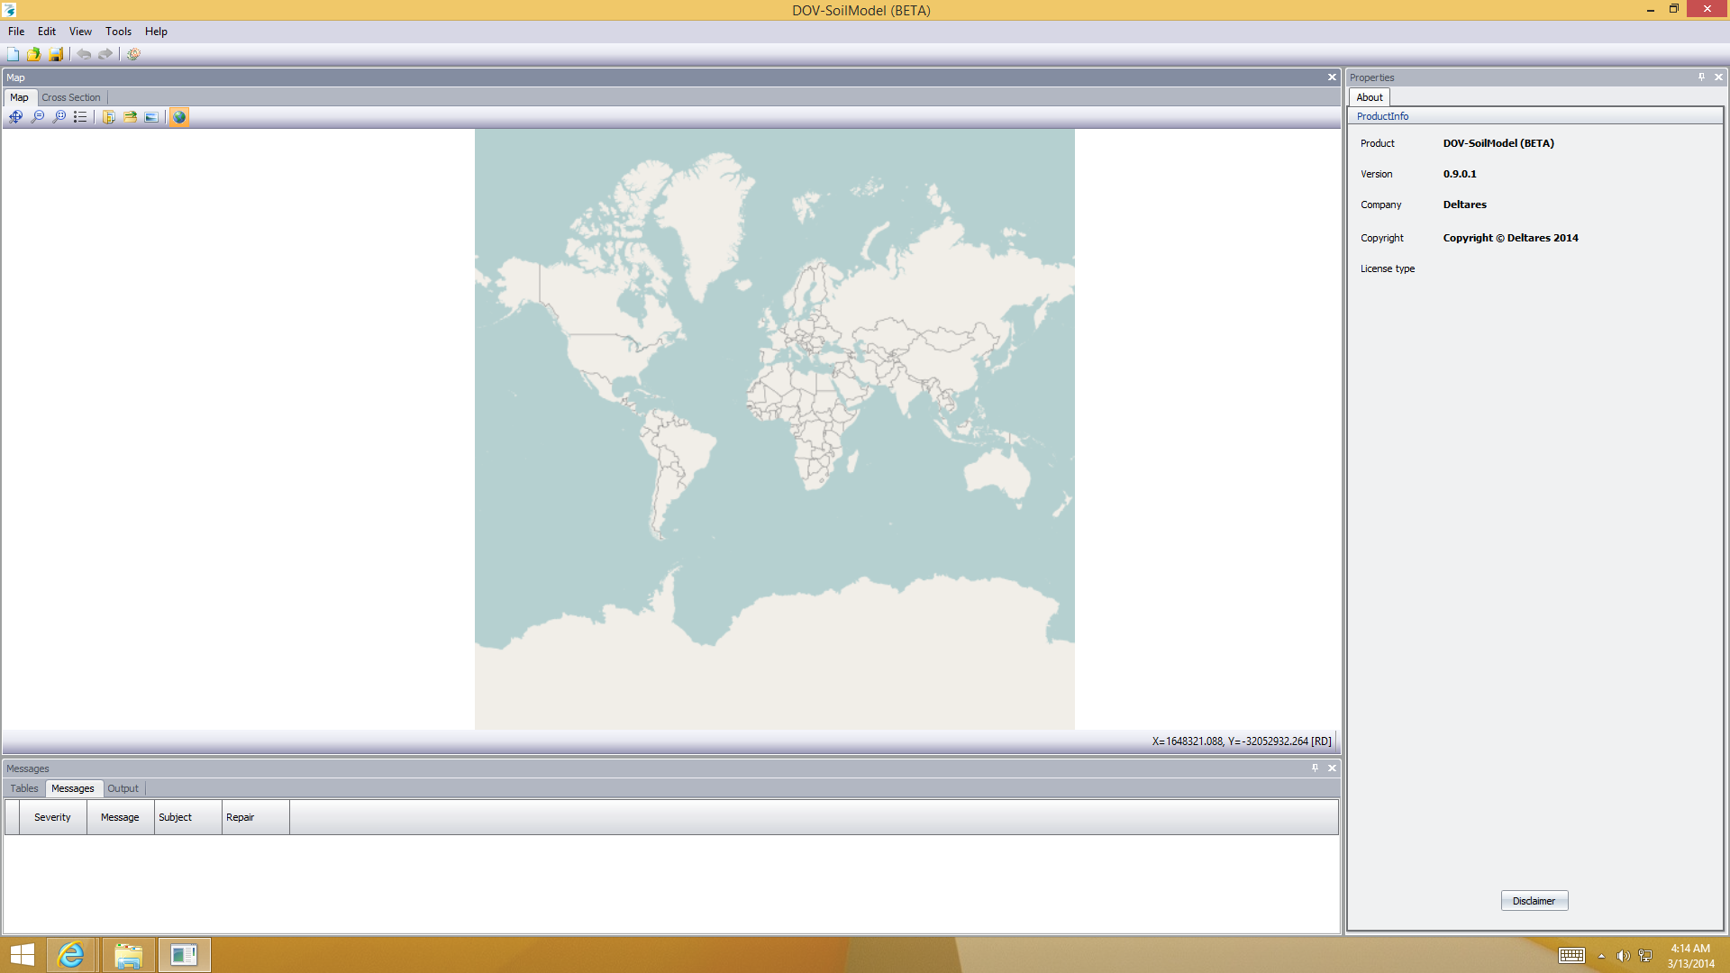

 | General – Cross Section
Do the following buttons work?
Pan
Zoom to extents
Zoom to extents and reset aspect ratio
Zoom rectangle
Options

 | General – Toolbar
Do the following buttons work?
New
Open
Save
Undo
Redo
Reset
Filter mechanism (when selected, filter in tables should be greyed-out)
Filter all/(non) probabilistic
 | General – Menu – File
Does the following work?
New
Open
Save
Save as
Import (in order)
Soils from database
1D Profile from file
2D Profile from file
Surfacelines.csv
Characteristicpoints.csv (only possible after import surfacelines.csv)
Soilsegments from file (only possible after import of 1D profiles) as csv
Soilsegments from file (only possible after import of soilsegments as csv) as shape
NB: if attribute SegmentId fails in soilsegments.shp a dialogbox should occur with excisting attributes
Import (random order)
CPT from file (not all GEF’s import; only real digital files, not scanned tiff-files)
boring from file (not all GEF’s import; only real digital files, not scanned tiff-files)
DAM import dataset
Old Project database
Exit

Does the program show previous opened projects and can you open them?

 | General – Menu – Edit
Does the following work?
Undo
Redo
Delete (option should be removed: DSB-342)
 | General – Menu – View
Does the following work?
Reset
Map
Cross Section
Length profile
Properties
Validation Messages
Log
Tables
Materials
CPT’s
Borings
1D profiles
2D profiles
Surfacelines
Segments
Stress curves (not test data available yet)
Bond stress curves (not test data available yet)

 | General – Menu – Tools – Program options (this is properties on the right of the program)
Initial project, can you choose between:
New project
Last project

Language, can you choose between:
English
Dutch

Multi Core, can you choose the Number of cores? (should be disabled)

 | General – Menu – Tools – Units (this is properties on the right of the program)
Fraction, can you choose between:
-
%
‰
Ppm

Length, can you choose between:
M
Mm
Cm
Inch
Ft
Km

Tiny length, can you choose between:
µm
mm

Angle, can you choose between:
Deg
Rad
Grad
Tan
Cot

Time, can you choose between:
s
min
hourunitID
dayunitID
yearunitID

Weight, can you choose between:
kN/m^3
N/m^3
Lb/in^3
MN/m^3
Lb/ft^3

Pressure per length, can you choose between:
kN/m
N/m
kN/cm
lb/in
in/ft
kip/inch

Pressure, can you choose between:
kN/m^2
N/m^2
Pa
kPa
MPa
kN/cm^2
psi
ksi
N/mm^2
GPa

Permability, can you choose between:
m/s
m/min
m/hr
m/day
cm/s
mm/s

Probability, can you choose between:
%
‰
β

 | General – Menu – Help – About
 | Is the correct info shown?
 | Tables – Materials (at the bottom of the program)
Do the following buttons work?
Add
Delete
Cut
Copy
Paste
Fits column
Edit
Export

Can you choose between:
All
DGeoStability parameters
DGeoStability C-Phi model
DGeoStability Su Calculated model
DGeoStability Su Measured model
DGeoStability Su gradient model
Shear strength parameters
Shear strength input
Shear strength model
Piping
Flow Slide – Global and Detailed
Unit weights
Probabilistic
StiffnessParameters
Bishop probabilistic
Flow Slide – Advanced Liquefaction (Sliq2D)
Flow Slide – Advanced Breaching (HMBreach)

 | Tables – Materials (now choose All and Add a material)
Can you:
Change the name
Select a color
Type something at ‘Description’

Does everything you change also changes in the properties menu on the right of the program?

Can you check or uncheck “ Use default probabilistic values” ?

Can you check or uncheck “ Use POP” ?

Check the values:
Unsaturated unit weight
Min: 0,001
Max: 100

Overdry unit weight
Min: 0,01
Max: 100

Saturated unit weight
Min: 0,001
Max: 100

Cohesion
Min: 0
Max: 1.000.000.000

Friction angle
Min: 0
Max: 89

Bedding angle
Min: 18
Max: 72

Diameter D70
Mi : 0,01
Max: 1.000.000

Permeability X
Min: 0
Max: 1000

Strength increase exp
Min : No min value
Max : No max value

Whites constant
Min: -0,1
Max: 1

Diameter D90
Min : 0,01
Max : 1.000.000

Emod
Min: 0
Max: 9.000.000.000

Cu active bottom
Min: 0
Max: 1.000.000.000

Su active top
Min: 0
Max: 1.000.000.000

Su passive bottom
Min: 0
Max: 1.000.000.000

Cu passive top
Min: 0
Max: 1.000.000.000

Ratio Su/Pc
Min: 0
Max: 1.000.000.000

Active ratio Su/Pc
Min: 0
Max: 1.000.000.000

Passive ratio Su/Pc
Min: 0
Max: 1.000.000.000

OCR
Min: 0
Max: 1.000

POP
Min : 0
Max : 10.000

Su Top
Min : 0
Max : 10.000.000

Su bottom
Min : 0
Max : 10.000.000

Su gradient
Min : 0
Max : 10.000.000

Correlation friction angle
Min: -1
Max: 1

Excess porewater pressure
Min: -100.000.000
Max: 100.000.000

Pore pressure factor
Min: 0
Max: 1

D50
Min: 0,01
Max: 1.000.000

D15
Min: 30
Max: 2000
n
Min: 0,3
Max 0,6

nmin
Min: 0,3
Max: 0,6

nmax
Min: 0,3
Max: 0,6

Dr.
Min: Can’t fill in
Max:

Psi 5m
Min : No min value
Max : No max value

Epsvoldm0
Min: 0
Max: 0,03

Ks0
Min: 10.000
Max: 140.000

S2
Min: 1,1
Max: 1,4

Gamma grain
Min: 20
Max: 30

Permeability
Min: Can’t fill in
Max:

m [-]
Min: 1,5
Max: 3

r [-]
Min: 7
Max: 7

u [-]
Min: 0,5
Max: 1,5

f [-]
Min: 0,5
Max: 1,5

FormReferencePnCaption
Min : 0
Max : 1

Slope restprofile
Min : No min value
Max : No max value

Dilatancy type, can you choose between:
Phi
Zero
- Phi
User defined Phi

Input mode, can you choose between:
Mean
Design

Shear strength model, can you choose between:
None
C phi
Stress table
Pseudo values
Su measured
Su calculated
Su gradient

Soil type, can you choose between:
Sand
Peat
Loam
Clay
Gravel

Distibution for the stochasts, can you choose between:
Deterministic
Normal
Truncated normal
Log normal
Triangular
Uniform
Exponential

Can you select or deselect:
Use default probabilistic values
Use POP
Use nail
Default shear strength input
Default shear strength model

Tables – Materials (sometimes it seems like there is a variable duplicated, but one is the deterministic value, the second is the stochastic value. Clicking on last one, there will appear an edit screen:

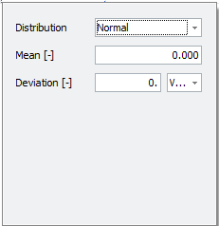

Check for the following variables if this screen pop ups and if it works.

Check:
Unsaturated unit weight [kN/m³]
Saturated unit weight [kN/m³]
Cohesion
Friction angle
Permeability X [m/s]
Diameter D70 [µm]

 | Tables – CPT’s
Do the following buttons work?
Add (add a CPT by clicking on the green + button)
Delete

 | Tables – Borings¹
Do the following buttons work?
Add (add a Boring by clicking on the green + button)
Delete

 | Tables – 1D profiles
Do the following buttons work?
Add
Delete
Cut
Copy
Paste
Fits column
Edit unit: should be disabled
Export

 | Tables – 1D profiles (add a profile by clicking on the green + button)
Can you type a name?

Does everything you change also changes in the properties menu on the right of the program?

Check the values:
X (RD)
Min: No min value
Max: No max value

Y (RD)
Min: No min value
Max: No max value

Bottom level
Min: No min value
Max: No max value

Probability
Min: 0
Max: 100

Does Location change when you change the X and Y coordinate?

 | Tables – 2D Profiles
Do the following buttons work?
Add
Delete
Cut
Copy
Paste
Fits column
Edit unit (only abled when cell in column with an unit is selected)
Export

 | Tables – 2D Profiles (add a profile by clicking on the green + button)
Can you type a name?

Does everything you change also changes in the properties menu on the right of the program?

Check the values:
X Start
Min: No min value
Max: No max value

Y Start
Min: No min value
Max: No max value
X End
Min: No min value
Max: No max value

Y End
Min: No min value
Max: No max value

Can you add a ‘change log’ message?

 | Tables – SurfaceLines
Do the following buttons work?
Add
Delete
Cut
Copy
Paste
Fits column
Edit unit (disabled)
Export

 | Tables – SurfaceLines
 | Can you type a name?
 | Tables - SoilSegments
Do the following buttons work?
Add
Delete
Cut
Copy
Paste
Fits column
Edit units (disabled)
Export

 | Tables – SoilSegments
Can you type a name?

Does everything you change also changes in the properties menu on the right of the program?

Mechanism, can you choose between:
None
Stability
Settlement
Piping Level 1
Piping
Koswat
FlowSlide
Overtopping
AnchorLoading
DAM
Structures
Block Revetment
AssessmentLevel
Dunes
Asphalt Revetment
 | Tables – Stress curves
Do the following buttons work?
Add
Delete
Cut
Copy
Paste
Fits column
Edit
Export
 | Tables – Stress curves
Can you choose between:
All
StressCategory

Can you fill in something at:
Description
Name

Number of tests
Min: 0
Max: 999.999.999
 | Tables – Bond stress curves
Do the following buttons function?
Add
Delete
Cut
Copy
Paste
Fits column
Edit
Export

 | Tables – Bond stress curves
Can you fill in something at:
Name
Description
 | Properties– 2D Profile - Grensspanningen
 | Can Grensspanningen be added in 2D profile?
 | Properties – Segment
Profiles – Does menu buttons function?
Profiles - Can values of probability be edited?
Profiles - Can profile be picked?
CPTs for this segment - Can you add a cpt to the segment?
Borings for this segment - Can you add a boring to the segment?
If mechanism is stability:
Identification: Can surfaceline be added to segment (with and without) zones?
Does 2D profiles show in cross section window?
Are these profiles added to the 2D profiles table?
 | Cross section- cross section – Segment
 | Does crossection and selection in properties window change when selecting in filmstrip?
 | Cross section- cross section – 1D Profile
Does option button (right mouse click) function?
Do checkboxes in properties window function?
Can a cpt/boring be added?
Can a surfaceline be added to create a 2D profile? (default with zones and undetermined soil as fill material)?
Is this profile added to the 2D profiles table?
 | Cross section- cross section – 2D Profile
Does option button (right mouse click) function?
Do checkboxes in properties window function?
Can a cpt/boring be added?
Can a 1D profile be added?
Can a mechanism location be added?
 | Cross section- cross section – Segment
Does option button (right mouse click) ?
Do checkboxes in properties window function?
Do added cpt/boringen show in length profile?
Can Segment be split?
Does spilt show in other windows (map, tables)?
(default with zones and undetermined soil as fill material)?

CPT and borings are read only, so only adding and deleting can be tested.
No testdata available yet
No test data available.

