Summary
This document describes how the DAM sources are kept in source version control. Currently that is in a Subversion repository that is hosted on servers on premise within Deltares. New Deltares policy dictates that the Subversion repositories are to be migrated to Git. For most of Deltares products the Git repositories are put in GitHub.
This document is an action plan how to perform the migration from Subversion to GitHub.

Current Status
Currently the following repositories are used for DAM
Name | Link
DAM | https://repos.deltares.nl/repos/dam
DAM projects | https://repos.deltares.nl/repos/DAM-Projecten

DAM
This is the main repository containing all the sources of DAM applications and its components.
The layout can be seen in the picture below.
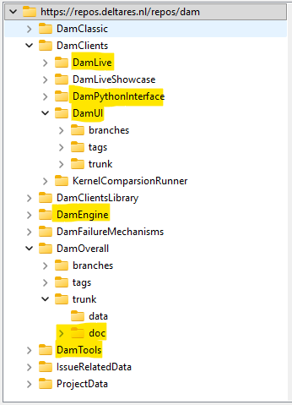
Note that the highlighted projects all contain branches/tags/trunk. See for example DamUI.
Only the highlighted parts should be migrated.
The folders IssueRelatedData and ProjectData contain a lot of data, that could be migrated to another location (not a repository), e.g. the P-drive.
In the table below the relevant parts are shown with the size of the data they contain (only the trunks).
Project | Size (in MB)
DamLive | 190
DamPythonInterface | 32
DamUI | 817
DamEngine | 90
DamOverall-doc | 53
DamTools | 107
IssueRelatedData | 15500
ProjectData | 1850

DAM projects
This repository (do not confuse this with the folder ProjectData in the Dam repository) contains some projects and an early version of the DAM manual. This repository can be deleted. Its size is 247 MB

DAM issues data
This repository contains data that belong to issues. Because of the size of the data, the data is not stored as attachment with the issues, but stored in this repository. The size of the full repository (only data, no version information) is currently 16 Gb.
Maybe we should also delete this repository, and store the data on another location (e.g. the P-drive).

Migration plan
Migration of the DAM repositories will result in the following parts.

3 git repositories

DamEngine
The data will be migrated from the trunk exactly as it was in stored in the SVN repository. See picture below.
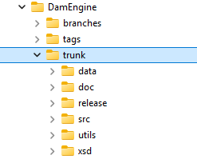
Only the trunk will be migrated with the complete history.

DamClients
DamUI, DamLive and DamPythonInterface will be migrated in the DamClients repository without history. The layout will be as follows.
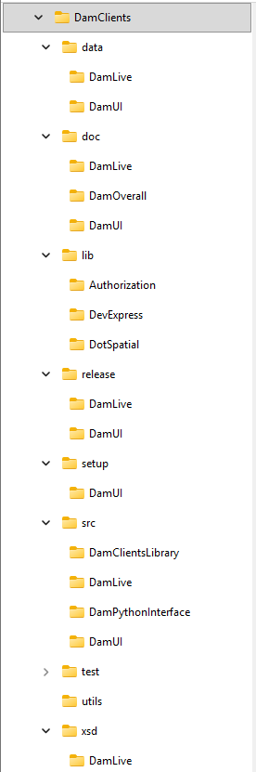

DamTools
The data will be migrated without history and without the branches/tags/trunk.
See picture below.
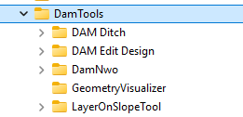

Storage
Data stored in DAM issues data will be moved from the repository to a storage location.

Archive of SVN repository DAM
The original SVN repository of DAM will still be alive, because bugfixes will have to be made in this repository. After the next release of DAM and DAMLive this repository can be set to read-only and will only be accessed to view the history of the code.

