Summary
This document describes how the DAM sources are kept in source version control. Currently that is in a Subversion repository that is hosted on servers on premise within Deltares. New Deltares policy dictates that the Subversion repositories are to be migrated to Git. For most of Deltares products the Git repositories are put in GitHub.
This document is an action plan how to perform the migration from Subversion to GitHub.

Current Status
Currently the following repositories are used for DAM
Name | Link
DAM | https://repos.deltares.nl/repos/dam
DAM projects | https://repos.deltares.nl/repos/DAM-Projecten

DAM
This is the main repository containing all the sources of DAM applications and its components.
The layout can be seen in the picture below.
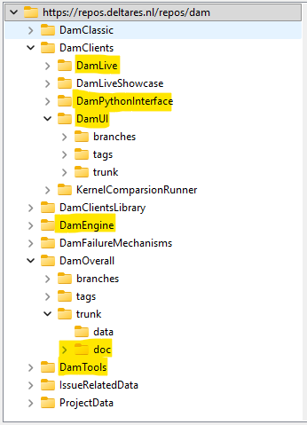
Note that the highlighted projects all contain branches/tags/trunk. See for example DamUI.
Only the highlighted parts should be migrated.
The folders IssueRelatedData and ProjectData contain a lot of data, that could be migrated to another location (not a repository), e.g. the P-drive.
In the table below the relevant parts are shown with the size of the data they contain (only the trunks).
Project | Size (in MB)
DamLive | 190
DamPythonInterface | 32
DamUI | 817
DamEngine | 90
DamOverall-doc | 53
DamTools | 107
IssueRelatedData | 15500
ProjectData | 1850

DAM projects
This repository (do not confuse this with the folder ProjectData in the Dam repository) contains some projects and an early version of the DAM manual. This repository can be deleted. Its size is 247 MB.

Migration plan
Migration of the DAM repositories will result in the following parts.

3 git repositories

DamEngine
The data will be migrated from the trunk exactly as it was in stored in the SVN repository. See picture below.
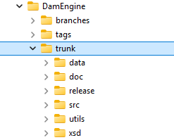
Only the trunk will be migrated with the complete history.
An extra folder will be added: Tools. In that location the source of GeometryVisualizer wil be stored that was first stored in the DamTools folder of the original repository. The other tools will not be migrated.

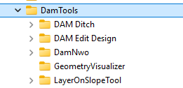

DamClients
DamUI and DamLive will be migrated in the DamClients repository without history.
Mabye, if possible, we keep part of history of DamClients repository (the history of the DamUI trunk of the original SVN repository).
The layout will be as follows.
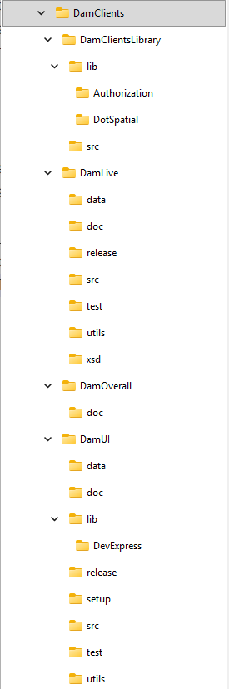

The only real clients are DamLive and DamUI.
DamClientsLibrary is put on the same level, because it contains sources shared by DamLive and DamUI.
DamOverall is used for documentation that apply to the whole Dam system. E.g. overall architecture of DamEngine, DamUI and DamLive, projectplans, scrum info etc.

DamPythonInterface
The data will be migrated from the trunk exactly as it was in stored in the SVN repository. See picture below.
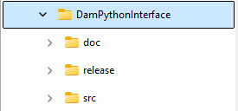

Only the trunk will be migrated with the complete history.

Storage
Data stored in DAM issues data and DamProjectData will NOT be moved from the repository to a storage location. For the lifetime of the original SVN repository they will still be available from that location.
For new Dam project data or new issue related data a location need to be found on a storage location. E.g. the P-drive.

Archive of SVN repository DAM
The original SVN repository of DAM will still be alive, because bugfixes will have to be made in this repository. After the next release of DAM and DAMLive this repository can be set to read-only and will only be accessed to view the history of the code and data.
On January 1st of 2030 this SVN repository will be put in archive.

