Keywords
Stochastic subsoil schematization, soil profile, soil properties, macro stability, piping

Summary
This document contains the requirements and a global description of the technical design for the application D-Soil Model, which will be a part of the WTI 2017 software. The application supports the (stochastic) subsoil schematizations for the failure mechanism macro stability and piping. A subsoil schematization for an area or segment consists of 10/20 soil profiles and soil material properties.

Samenvatting
Dit document bevat de eisen aan en globale beschrijving van het technisch ontwerp voor de applicatie D-Soil Model welke deel uit maakt van de WTI-2017 software. De applicatie ondersteunt de (stochastische) schematisering van de ondergrond voor de faalmechanismen Macro Stabiliteit en Piping. Per gebied dan wel segment bestaat deze schematisering uit zo’n 10 tot 20 grondprofielen.

References
1209430-003-0SC-0009-7 WTI 2017 D-Soil Model Requirements and functional design

Version | Date | Author | Initials | Review | Initials | Approval | Initials
1.0 | Jun. 2014 | ing. J. Bokma |  | drs. R. Brinkman |  | ir. J. Icke
 |  | ir. J.J. Beckers
1.1 | Jun. 2015 | ir. J.J. Beckers |  | ing. J. Bokma |  | ir. J. Icke
1.2 | Dec. 2015 | Ing. B. Adriaanse |  | drs. R. Brinkman |  | Ir. J. Icke
1.3 | Jun. 2016 | ing. J.Bokma |  | dr. ir. H. van Putten  Tom The |  | ir. J. Icke
1.4 | Aug. 2016 | B.S.T.I.M. The |  | dr. E.J. Spee  dr. ir. H. van Putten |  | Ir. J. Icke
1.5 | Dec. 2016 | B.S.T.I.M. The |  | ing. J. Bokma  dr. ir. H. van Putten |  | Ir. J. Icke

State
final

Contents
1 Introduction 3
1.1 Purpose and scope of this document 3
1.2 Other system documents 4
1.3 Assumptions and constraints 5
2 Technical Design 7
2.1 General 7
2.2 System Architecture 7
2.3 Architectural choices 7
2.3.1 Application Framework 7
2.3.2 Validation 8
2.3.3 Import logging 8
2.3.4 Database protection 8
2.4 Data description 8
2.4.1 Measured data 8
2.4.2 Modelled data 10
2.5 Data classes 14
2.6 Database description 15
2.6.1 General 15
2.6.2 Schema 16
2.7 Functionalities 17
2.7.1 Data import 17
2.7.2 Data export 17
2.7.3 Application Toolbar 17
2.7.4 Tables 18
2.7.5 Map 19
2.7.6 Viewer/Editor 20
2.7.7 Length Profile 22
2.7.8 Property Editors 23
2.7.9 Validation Messages 23
2.7.10 Log Messages 24
2.7.11 View Menu 24
2.7.12 Tools Menu 24
2.7.13 Help Menu 24
3 Literature 25

Introduction

Purpose and scope of this document

This document contains the technical design for D-Soil Model.
The document will not give any background on the context of the WTI project. For this purpose the reader is referred to the WTI2017 and to its supporting technical reports and their background reports underneath.
This document will describe how the requirements and functional design are implemented in the program.
In the total scope of the WTI-project, D-Soil Model can be seen as the tool to provide the soil schematisation, see the next diagram:

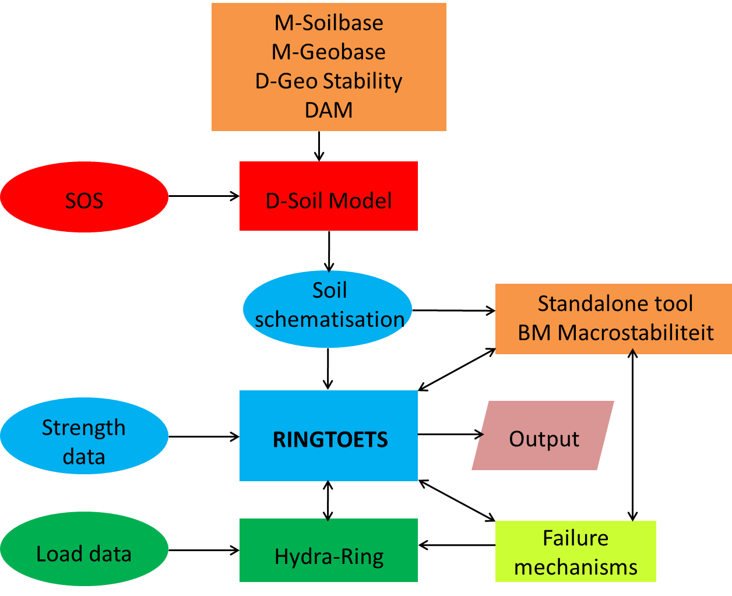
A
E
D
C
B

D-Soil Model is connected to several other components of the WTI2017 as follows:

- Data can be imported from the SOS database.
- Data can be imported from data that is used by or created by tools that are not part of WTI (e.g. DAM or D-Geo Stability). This also includes data described by industry standards as GEF-CPT for cone penetration tests (“Sonderingen” in Dutch) or GEF-Bore for borings (“Boringen” in Dutch).
- D-Soil Model is a pre-processor that supports the creation of the soil schematization
- The Ringtoets application can read the soil schematization
- The standalone tool BM – Macrostabiliteit can read the soil schematization.

Other system documents

The full documentation comprises the following documents.
Title | Content | Authors
Functional Design [Lit 1] | Description of the requirements and functional design. | Irene vd Zwan
Technical design | This document | John Bokma  Jay Beckers Bart Adriaanse  Tom The
Technical specification  [Lit 2] | Description of the arguments and usage of different software components, generated from in-line comment with Doxygen. | John Bokma
Test plan [Lit 3] | Description of the different test levels of the V model as prescribed by the overall test plan. | Virginie Trompille
Test report [Lit 4] | Actuated results of the test plan. | Virginie Trompille
Geo Data Model [Lit 5] | Description of the geotechnical data model | Rob Brinkman
Delta Shell Light technical documentation [Lit 6] | Programmers manual for the DelatShell Light library | Rob Brinkman

Assumptions and constraints

- As a general constraint, the development process needs to comply with the general process description for WTI software, contained in a separate document [Lit 8].

- As a general constraint, the program needs to comply with the relevant general requirements and further design rules for the programming, documentation and testing of WTI software. This set of requirements and rules is contained in a separate document [Lit 7].

Technical Design

General

The D-Soil Model data model is used by different Deltares calculation applications. The focus will be on the WTI program.
Note that in the functional design (Lit 1) there are lists of functional (Appendix E) and non-functional requirements (Appendix B). These requirements are met by implementing them in use cases that are described in chapter 2 of that document. In this document reference to the requirements are done by the prefix REQ, followed by the requirement ID (e.g. (REQ-CNS12, or REQ-NFR11). References to (parts of) the use cases are done by the prefix FD followed with the paragraph number (e.g. FD2.1.1).
The functional requirements are fully covered by the Use cases, so by implementing all the Use Cases, the functional requirements will be fulfilled. Also note that some paragraphs are mentioned more than once as some use cases can be met in different ways. It is also possible that such a use case is only fully met by combining different functionalities together.

System Architecture

The platform chosen for the User Interface is Windows, the minimal required version is Windows 7. For the development of the application, C# has been chosen as programming language and Visual Studio 2012 as the development environment. For development, the .Net Framework 4 is used as the basic framework, so the presence of the .Net Framework 4 in the Windows environment is a prerequisite for using the program.
Instead of a file, the application uses a file based database as means of data storage (so REQ-U132 is met). This is a SQLite database which, next to the program can be managed by the SQLite manager. Amongst others this is available as a plugin in Mozilla Firefox.

The reason to choose SQLite is that SQLite is a self-contained, server less, zero-configuration, transactional SQL database engine, and the code is public domain (So REQ-PSA3, REQ-PSA8 are met). This means that the database can be used without the need of a DBMS.
So a project-file for D-Soil Model is a single file, with the extension .soil and is a SQLite database conforming to the database schema as described in chapter 2.6.2. The project-file contains all the data that can be entered in D-Soil Model.

Architectural choices

Application Framework
First of all it was decided to use the Delta Shell Light framework for the development of this application. Reasons for this are:
- All Stand-alone Tools will be using this to create a general and similar look and feel for all the tools. This will help users greatly in working with the tools. Once a user is comfortable with one of the tools, he/she can find their way easily and quickly in all the other tools (So REQ-R7, REQ-U144 are met).
- It allows for faster development by providing easy data-binding, common UI-components, (de)serialization, translation and validation support (So REQ-U125, REQ-U126, REQ-U128 are met).
In the release documents the exact version of the DSL libraries will be mentioned (Protocol van Overdracht)

Validation
As this application does not perform any calculations, the choice is made to use continuous validation as there is no real validation moment (normally at the start of a calculation). Therefore, every change in the input is directly validated and if needed reported in the Validation log. In case of performance problems it can be decided to turn off continuous validation and add a validation option to the program (So REQ-U130 is met).

Import logging
Another choice is to handle the validation of imports separately due to the many import options and for clarity to the user. Errors and warnings encountered during import operations are logged in a separate log (Log messages). Errors are handled directly on import to keep the data in the project clean.
With both the Validation log and the Log messages, the error handling within the application is ensured. This ensures that FD2.7 (Error handling) from the functional design is met. Next to that, the continuous validation handles the check on the total probability of occurrence as described in FD2.3.3, FD2.3.4 and FD2.3.6 from the functional design (Also REQ-U130 is met).

Database protection
The databases will not be protected against changes outside of the application. The integrity of the database is handled in the application itself. External changes of the database could compromise the database.

Data description

The model class diagram can be found in appendix A.
The data that makes up a model can be divided into the following categories: measured data and modelled data.
Measured data is data from actual measurements, like cone penetration tests (CPTs) or Borings (boreholes). It is generally imported into the D-Soil Model application (see 2.7.1) and can be viewed and edited in the tables and property editors (see 2.7.4, 2.7.8)
Modelled data refers to the parts of the data model that are based on conclusions, estimations, and interpolations, etcetera which comprise the model. As modelled data is the result of the modelling and calculation in applications that use D-Soil Model, the resulting modelled data can still be imported into D-Soil Model and altered or extended in the fields of the tables and property editors.

Measured data

Soil
Soils define specific soil configurations in the data model. This also includes all functionality from M-Soilbase. However, only parameters that are directly related to the soil are stored, therefore data related to water pressures falls outside the scope of D-Soil Model. Soil materials can be allocated to one or more soil layers in one or more soil profiles.
Within Soil data, the data properties can be divided into two other categories, Probabilistic or Non-Probabilistic, based on whether probability is an aspect regarding the property. For a Soil, both the probabilistic and the non-probabilistic properties can be defined and which property type is used, depends on the application.
The non-probabilistic properties for a Soil are specific soil properties per soil. The value is unambiguous and generally refers to some geotechnical aspect of the soil. The soil materials can be named or renamed.
The probabilistic properties for a Soil are properties that can be comprised of different possibilities (based on different measurements). One probabilistic property is defined by a number of probabilistic variables.
Probabilistic variables are defined by their distribution type, being deterministic, normal or log normal, and the stochastic parameters mean, standard deviation (standard deviation only for normal and log normal) and the property shift for log normal. A characteristic value is also part of the probabilistic variables, which can be used for the determination of the calculation value.
Note that both non-probabilistic and probabilistic properties, including the characteristic value, are independent from the application or calculation they are used in. However, the calculation value may depend on the calculation it is used for. This is a consequence of the way non-probabilistic and probabilistic properties are calculated into calculation values, which is calculation specific (this is not a part of D-Soil Model).
Soil properties can only be shown and edited through Tables and Property Editors (see 2.7.4, 2.7.8)

CPT

Cone penetration test data (also called CPT) is stored in ConePenetrationTestData in the data structure. The data for CPTs is available through Tables and through the Property Editor. Some data is only shown graphically in the views (like qc, level, water pressure, friction and friction number). Note that the data itself cannot be edited.
The local location of a CPT can also be modified in the Viewer/Editor display of a 2D Profile by dragging within the Profile. This will not affect the depth or the real world position of the CPT.
The determination of soil parameters from CPT’s will not be supported in the application.

Boring

Borings define bore hole data in the data structure. In the Class Model it is stored in the class Boring. The data for Borings is available through Tables and through the Property Editor. Some layer data is only shown graphically in the cross section views. Note that the data itself cannot be edited.
The local location of a Boring can also be modified in the Viewer/Editor display of a 2D Profile, by dragging within the Profile. This will not affect the depth or the real world position of the Boring.
The determination of soil parameters from Borings will not be supported in the application.

Modelled data

1D Profiles

1D Profiles define soil layer composition in the data, on a single location on the map. In the Class Model it is stored in the class SoilProfile1D. A 1D Profile is defined by a unique name and is comprised of connecting and non-overlapping layers that each have a top level, bottom level, height and a soil, each with their own layer properties, which are presented in the property editors (see 2.7.8 Property Editors). Next to possible multiple layers, a 1D Profile has a geographical horizontal X and Y coordinate, its own top level, bottom level (which are in accordance with the soil layers top and bottom levels) and height, a location and a text field (log) where a user can make specific notes about the profile.
A 1D Profile can also be viewed and edited graphically as shown in the next image:
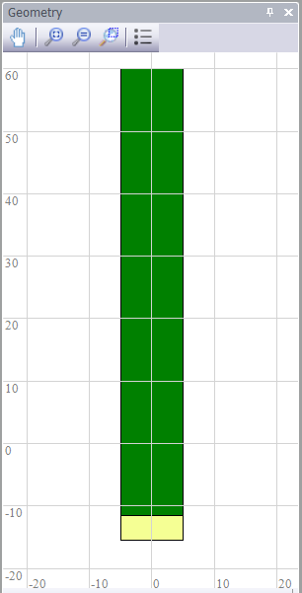
Image: 1D profile

2D Profiles

2D Profiles define soil layer composition in the data, along a straight line on the map. In the Class Model it is stored in the class SoilProfile2D. A 2D Profile is defined by a unique name. A 2D profile is comprised of surfaces. These surfaces have a name, a soil and a geometry surface, which is comprised of points, defined by X/Z coordinates that set the surface points on the plane of the 2D Profile. Note that the X/Z coordinates are purely local. A 2D profile has no specific global coordinates as it has no specific location. Instead, a 2D profile is linked to a segment for which it is representative.
Furthermore, a profile can contain a location for the reference line and a text field (log) where a user can make specific notes about a profile.
A 2D Profile can also be viewed and edited graphically as shown in the next image:

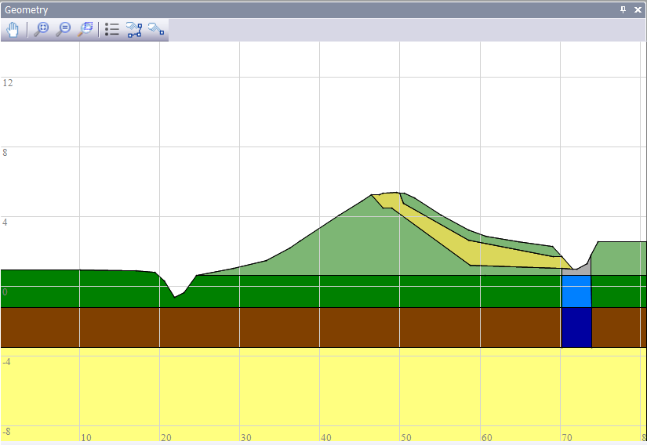
Image: 2D profile
Next to that, a 2D profile holds information about the pre-consolidation stresses belonging to it. The pre-consolidation stresses are a list of stress points of which the location is drawn in the editor. Next to its location, each stress point can hold a probabilistic as well as a non- probabilistic value for the stress. All pre-consolidation stresses can be edited using property editors (2.7.8). With this, FD2.4.4 (Define yield stresses per 2D soil profile) from the functional design is met.

Mechanism specific representative 1D soil profiles in a 2D soil profile
For the mechanisms the location for a (representative) 1D soil profile can be pointed out within a 2D soil profile (as shown in the image below). This is required for Piping. However, all supported mechanisms in the Delta Shell Light framework can be assigned to a 1D location on a 2D profile. This 1D location will have to be transformed into an actual 2D soil profile to be able to be used in calculations. This transformation will have to be done in the Plugin or calculation application using the D-Soil Model output.
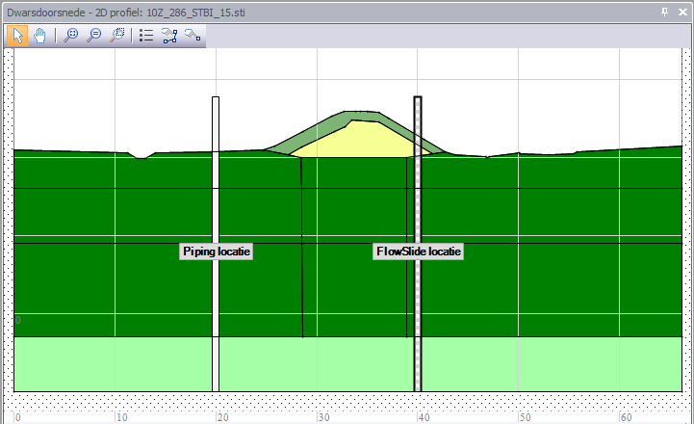
Image: 2D profile with a Piping and a 1D location

Compilation of 2D soil profiles from 1D soil profiles and surface lines
A 2D profile can be generated from a 1D soil profile and a surface line. In the 1D profiles view in the Viewer/Editor (when a 1D profile has been selected in the 1D profiles table), a context menu option provides the possibility to select a surface line from the Surface Lines table and combine the 1D profile with the surface line to a 2D profile.
In the profiles overview for the Soil Segments, a similar option, for all 1D profiles in a (stochastic) soil model can be applied. On the property panel for the segment, a surface line can be set, to create 2D profiles for the segment, form the original 1D profiles of the segment.
A default fill material can be set, that is used to fill the areas of the 2D profile that are created because of the shape of the surface line, below the surface line, however above the upper boundary of the top layer of the 1D profile.

Layer and Surfaces properties

The application must support layer (1D) and/or surface (2D) properties, these are presented to the user in the property editors (see 2.7.8 Property Editors). Layer/surface properties are information which is related and can be allocated to a soil layer/surface, within a 1D or 2D Profile. D-Soil Model supports the allocation of a soil material to one or more soil layers/surfaces in one or more soil profiles. A soil layer/surface in a soil profile can be defined in profile view as an aquifer or aquitard as layer/surface property. With this, FD 2.4.2 and FD 2.5.2 (Define aquifer layers per soil profile) from the functional design are met.
For 2D-profiles the pre-consolidation pressure can be entered as a profile property. If this pressure is a profile property it can be entered as a point in profile view.

Surface lines and Characteristic points

Surface lines define the surface of the ground in 2D. Surface lines are made up of geometric points (i.e. points defined in XZ-coordinates). In the Class Model surface lines and characteristic points are stored in the class SurfaceLine2. A surface line for a dike profile can contain characteristic points that determine the geometry of the profile. Two examples of characteristic points are the "Dike toe at river" and the "Shoulder top outside". The characteristic points within D-Soil Model are stored in the database. The task of combining the locally present surface line with stochastic schematized subsoil (see 2.4.2.8 Stochastic subsoil modelling) is the responsibility of the application that uses D-Soil Model.

Segments

A segment is a geographical area in which modelled data are defined for a specific mechanism. In the Class Model it is stored in the class SoilSegment. Segments are defined as points defining a polyline or polygon. Note that only for a segment a mechanism is defined and not within the 1D or 2D profiles. 1D or 2D profiles may be used in multiple segments and therefore can be applied for different mechanisms.
At least the following failure mechanisms are supported: Piping and Macro Stability. The mechanisms determine how the user should model the soil composition for the segment to be complete so that calculation software can use the subsoil schematisations directly.
A segment represents a stochastic subsoil model (in Dutch “Stochastische Ondergrond Schematisatie”, abbreviated to SOS) defined by stochastic subsoil scenarios. Such a scenario (called SOS scenario) is defined by one or more profiles (1D or 2D) and a probability of occurrence for each of them. The total probability should be 100% and all available SOS scenarios per segment must be presented. Preferably, available CPT’s and Boreholes can be matched with a scenario for stochastic schematized subsoil (see 2.4.2.8)
Segments are displayed in Viewer Editor 1D/2D in combination with Viewer/Editor Filmstrip. Next to that the data can be shown and edited through Tables and Property Editors (see 2.7.4, 2.7.8). For segments defined for the stability mechanism, combining all of its 1D soil profiles with a surface line to convert all 1D profiles to 2D profiles is offered from within the property editor when appropriate. With this, FD2.2.1.3 (Soil segments (stability) can be combined with surface line) from the functional design is met.
CPT’s and Borings can be related to one or more segment(s). This relation can be pre-defined in a GIS. If it is not, a user can allocate Borings and CPT’s to a segment. All available ground investigation information (all assigned Borings and/or CPT’s in a segment) can be scrolled through.

Stochastic subsoil modeling

A segment can have multiple possibilities for the subsoil composition. This probabilistic aspect of the soil composition can be modelled per segment. Stochastic subsoil modelling is the process by which the user is allowed to define multiple soil profiles for a soil segment and a probability of occurrence per soil profile and thus per failure mechanism for that segment (see the image below).

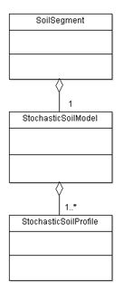
Image: Stochastic Soil Model class structure
The soil profiles can be either 1D or 2D soil profiles. The combined probabilities for all profiles that comprise one specific segment have to add up to a hundred per cent.
The user can get an overview of the soil profiles that make up the (stochastic) subsoil composition by clicking the rows in the list of profiles upon which the Viewer/Editor will show the related profile with its name and probability in the header of the component (see 2.7.6 Viewer/Editor).

Stochastic soil profiles (1D)
A stochastic 1D soil profile has a possibility of occurrence within its Stochastic Soil Model (which is attached to a Soil Segment), but the top level boundaries can also have a stochastic variation (as shown in the image below). This stochastic variation is set between a maximum value top level value and minimum value top level value.
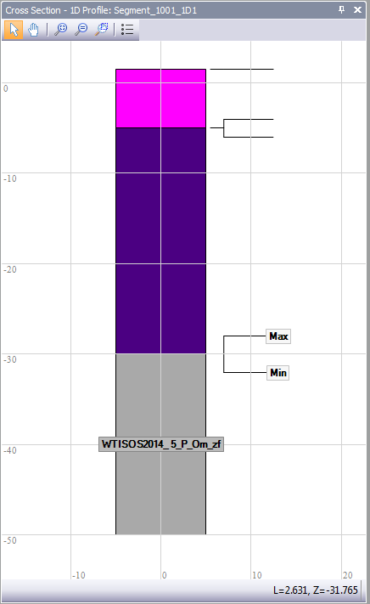
Image: StochasticSoilProfile1D

Data classes
Data are stored internally in the application following the Geotechnics design [Lit 5], in this way facilitating reuse of code among several WTI applications. The class diagrams in this document describe the way all items mentioned above are defined.
A D-Soil Model project will be stored in a single file containing the SQLite database, with the extension .soil. The database scheme is described in chapter 2.6.2.

The next diagram using Unified Modelling Language describes the general data model of all data objects as visible in the User Interface:
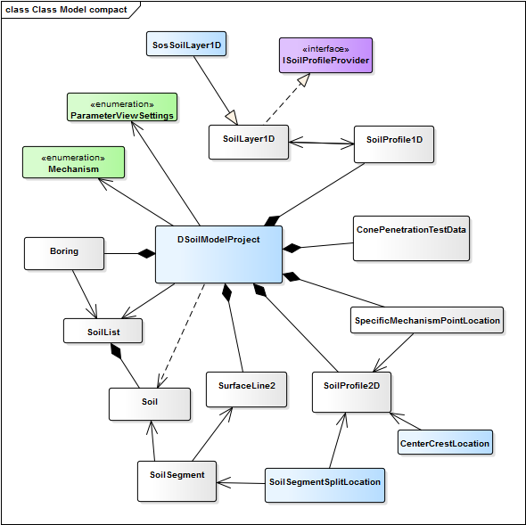

The light blue shaded classes are the classes used by D-Soil Model only; the light green shaded classes contain enumerations used by D-Soil Model. All other classes are used by D-Soil Model but are part of the Delta Shell Light frame work (DSL).

A more elaborate version of this model (also showing the properties) can be found in Annex A.

Database description

General
To facilitate interchange ability, the D-Soil Model database is available as a file based database without the need of a DBMS. The database is a SQLite database. SQLite is a self-contained, server less, zero-configuration, transactional SQL database engine, and the code is public domain.

Schema

As mentioned before the project file of D-Soil Model is a single file containing a SQLite database. The SQLite database conforms to the schema described In this chapter. The database schema of this file shows the tables of the database and the primary keys for the relationships between these tables. Note: StressCurve is obsolete and not used anymore in the program, but still present in the database.
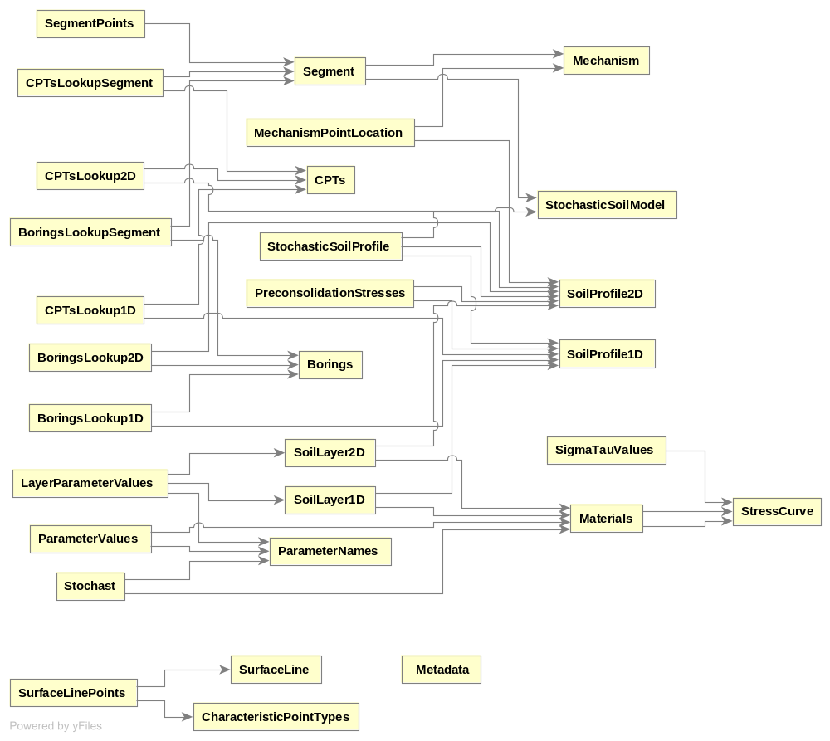

Functionalities

Data import

The functionality to allow import of data from existing data formats is provided to the user through the Import option in the menu item File. The application can at least import files from M-Geobase (*.mdb), D-Soilbase (*.mdb), D-GeoStability (*.sti, *.geo) and DAM import definitions (*.csv). With this, FD2.1.1 (Import data) from the functional design is met.
The following import commands are provided in the File menu of the application:
- Soils from database Imports soils from database:
Access soil database (*.mdb)
- 1D Profiles from file Imports one or more 1D Profiles from file:
Comma separated values file (*.csv).
- 2D Profiles from file Imports a 2D Profile from file:
Stability file (*.sti) or geometry file (*.geo).
- Surface lines from file Imports one or more surface lines from file:
Comma separated values file (*.csv).
- Soil segments from file Imports one or more surface lines from file:
Comma separated values file (*.csv) or shape file (*.shp).
- CPT from file Imports a CPT from file:
GEF CPT file (*.gef).
- Borehole from file Imports a Borehole from file:
GEF Borehole file (*.gef).

Data export

In both the Tables and Map view panels file export functionality is provided via a button on the toolbar (see 2.7.4.2 Table toolbar, 2.7.5.1 Map toolbar). The table data can be exported as csv (comma separated). With this, FD2.6.2 (Export (part of) tables) from the functional design is met.

Additionally, via the File menu a (sub) selection of the data present in a project (see 2.4 Data description) can be exported to a new D-Soil Model project. This selection can be made in the tables (see 2.7.4) or as a spatial selection on the map (see 2.7.5 Map). With this, FD2.3.1 (Save a selection of the WTI-SOS 2017 as a new project) from the functional design is met.

Application Toolbar

The application Toolbar is shown at the top of the application window and contains the following buttons:

- New Create a new project.
- Open Open an existing project.
- Save Saves the current data to file
- Rest Resets all windows to their default position.
- Mechanisme Select the type of mechanism to view.
- Parameters Select type of parameters to view.

The New option fulfils FD2.1.5 (Start a new project). The Open option fulfils FD2.1.6 (Open an existing project). The Save Option fulfils FD2.1.7 (Save current project) as well as FD2.4.1 (Save soil segments for the failure mechanism Macrostabiliteit binnenwaarts) and FD2.5.4 (Save soil segments for the failure mechanism Piping).

The mechanism and parameter selection options help to fulfil FD2.4.5 and 2.6.1 (selection of soil parameters) as both choices influences which soil parameters are actually shown in the material (or soil parameter) table.

Tables

The Tables component represents the current data. For example, the material soil properties can be created and modified in this table view. All data regarding the data structure (see section 2.4 Data description) is presented in rows and columns. The columns can show properties in a read-only (greyed out) or as an editable field. A user is only allowed to change properties that are not read-only. The Tables component allows the user to filter data and sort the data according to an ordering within a certain column. This filtering shall only be enabled if no specific mechanism has been specified in the mechanism selection (see 2.7.3 Application Toolbar).
Tables that contain data for which the user is allowed to modify that data, have a toolbar with operations. For data that does not allow editing (like CPTs), the table toolbar is partially disabled and the functionality of the remaining buttons can be redefined.
With this, FD2.1.3 (Show data in table) from the functional design is met.

Material table
The material table is used to display and edit all soils (materials) and their parameters. In its initial state, this table displays all available parameters for all models, non-probabilistic as well as probabilistic. However, this state can be filtered to display only parameters belonging to that filters:
- Mechanism filters from the application toolbar with options None (no filtering, local filtering on table toolbar enabled), Stability and Piping. With Stability or piping chosen, local filtering is reset to all and disabled.
- Parameters filter from the application toolbar with options All, Non-probabilistic and Probabilistic. Note that this filter is combined with either the Mechanism filter or the local filter.
- Local filter (categories filter) from the table toolbar with options All, Macrostabiliteit – Basis Module and Piping – RingToets.
Using the filters on this table, part of FD2.4.3 (Define soil parameters for the failure mechanism Macrostabiliteit binnenwaarts), part of FD2.5.3 (Define soil parameters for the failure mechanism Piping) and FD2.6.1 (Make a selection of the soil parameters) from the functional design are met.

Table Toolbar

The table toolbar can be shown at the top of the Tables panel and can contain the following buttons:

- Add Adds an entry (a data row) in a table*.
- Delete Removes an entry (a data row) from a table.
- Cut Cut the data in the currently selected field(s).
- Copy Copy the data in the currently selected field(s).
- Paste Paste the cut or copied data into the currently selected field(s).
- Fits columns Resizes all columns to fit all contents.
- Edit Edit the currently selected field.
- Edit Unit Edit the unit for the used type.
- Export Export the table to file:
CSV Files (*.csv)
Text files (*.txt)
PDF Files (*.pdf)
Excel files (*.xls, *xlsx)
Shape files (*.shp) (only if the data are geographically defined)
*: for total read only tables (such as CPTs and Borings table), the add functionality is replaced by an import functionality, allowing the user to import the specific data.
Depending on the type of data to be displayed in the table and required functionality for that type of data, buttons may or may not be available.

The Add, Delete, Copy and Paste buttons play a role in meeting (parts of) a number of requirements as set in the functional design:
- Add : FD2.3.5 (Make 2D soil profile), FD2.3.6 (Adding 1D and 2D soil profiles), FD2.3.8 (Add materials to the material table), FD2.4.3 (Define soil parameters for the failure mechanism Macrostabiliteit binnenwaarts), FD2.5.3 (Define soil parameters for the failure mechanism Piping),
- Delete: FD2.3.3 (Deleting soil profiles per soil segment)
- Copy/Paste: FD2.3.7 (Copy/paste segments for one failure mechanism to the next), FD2.6.3 (Import (part of) tables).

The table toolbar can contain a filter for its columns, like for Materials, where a filter can separate out columns for specific categories. Note that the selected filter not only influences the Material table but also the content of the Material property editor (see 2.7.8 Property Editors). This filter also helps to fulfil FD2.4.5 and FD2.6.1 (selection of soil parameters).

Map

The Map component shows the user a chart of the area regarding the current data. If geographic location is applicable and available in the data structure (see section 2.4 Data description), a map and appropriate markers are displayed. These markers on the map can be clicked to select the object and the appropriate object and its data is shown in the Property Editor.
The user can drag the map using the left mouse button and zoom in and out on the map using the mouse wheel or the first three buttons on the Map toolbar.
For CPT’s, borings and soil segments displayed on the map, labels can be shown on the map with the name/id of each entity. The user must be able to remove or customize these labels.
The user can use the map panel to split a soil segment into two smaller parts by selecting the location for the split interactively.

With this, FD2.1.2 (Show data on map) from the functional design is met.

Map Toolbar

The Map toolbar is shown at the top of the map panel and contains the following buttons:

- Zoom to extents Zoom to all layers, excluding a web layer. This zoom functionality shows the map in with the most overview and the least detail.
- Zoom to data Zoom until all contents fit on screen. This zoom functionality shows the map in with the most overview showing all geographic
locations with regards to the current data.
- Zoom to selected data Zoom until all selected contents fit on screen. This zoom functionality shows the map in with the most overview showing all geographic locations with regards to the current data.
- Zoom rectangle Zooms to a rectangle the user can define by dragging the mouse.
- Show legend Shows the legend of the current map in the Property panel.
- Open layer from file Open a map layer from a file.
- Export layers Export layers.
- Save map Save the current map as an image file.
- Select web layer Select the source material for the map display, like Open Street
Map, aerial imagery, etcetera.
- Selection Alllows for selection of a rectangular portion of the map in order to select segment data for saving as a separate project. With this, FD2.3.1 (Save a selection as a new project) from the functional design is met. Also when a selection has been made an option (via the popup menu on a right mouse click) is made available to automatically connect all selected cpts and boring to their nearest segment. With this, FD2.2.2 (Connect items in batch) from the functional design is met.
- Add location for split Add location for splitting the soil segment into two segments. After adding the location (halfway the segment), it can be dragged to the required position. Using the option provided in the popup menu, the actual split can be performed. Note that the selection made in the Mechanism box of the Application Toolbar controls which type of segments (all, stability segments or piping segments) are split. With this, FD2.3.2 (Splitting the soil segments per failure mechanism) from the functional design is met.

Viewer/Editor

The Viewer/Editor component is a Cross Section viewer that allows the user to view objects such as CPTs, Boreholes and profiles. And, if appropriate, edit these. The Viewer/Editor is context-dependent, meaning that it shows an object related to the selected data structure object. For example, for a 2D profile the layers and schematic visualisation of the materials is shown and for a CPT, the graph data for the CPT measurement is shown.
A 2D profile is an example of a geometry that the user can edit (e.g. by modifying surfaces or materials or drawing two dimensional soil layering), and CPT graphs cannot be altered by the user. For CPTs and Boreholes, the location can also be modified in the Viewer/Editor display of a 2D Profile, by dragging the location in the profile view.
With this, FD2.1.4 (Show data in a drawing) from the functional design is met.

Viewer/Editor 1D Soil Profile
When viewing/editing a 1D soil profile (and other data is available), the popup menu (available on a right mouse click) provides options to add cpt’s, borings and surface lines. On adding a cpt or boring, the item will also be drawn in the viewer/editor. On adding a surface line, the 1D soil profile will be combined with the chosen surface line in order to create a new 2D soil profile. With this, FD2.2.1.1 (1D Soil profile can be combined with :) from the functional design is met.

Viewer/Editor 2D Soil Profile
When viewing/editing a 2D soil profile (and other data is available), the popup menu (available on a right mouse click) provides options to add cpt’s, borings, 1D soil profiles, failure mechanism locations (per mechanism) and a reference line. On adding a cpt, boring, 1D profile or mechanism location, the item will also be drawn in the viewer/editor. After drawing the item it can be dragged to any position within the 2D soil profile. With this, FD2.2.3.2 (2D profile – cpt and boring) and FD2.3.5 (Make 2D soil profile; using 1D Soil profile) from the functional design are met. With mechanism location, it also covers FD2.5.1 (Define 1D soil profiles in 2D soil profiles)
On adding a reference line, an extra option to add a surface line will become available in the popup menu (note: only when at least one valid surface line containing a valid set of characteristic points is available). Upon adding a surface line, the 2D soil profile will be combined with the chosen surface line in order to create a new 2D soil profile (in the way as described in appendix B from the functional design. With this, FD2.2.1.2 and FD2.2.3.3 (2D Soil profile can be combined with :) from the functional design are met.

Viewer/Editor Surface Line
When viewing/editing a surface line (and other data is available), the popup menu (available on a right mouse click) provides options to add a 1D soil profile. On adding a 1D soil profile, the surface line will be combined with the chosen 1D soil profile in order to create a new 2D soil profile. With this, FD2.2.1.4 (A surface line can be combined with :) from the functional design is met.

Viewer/Editor Film Strip

The Viewer/Editor provides a way to compare stochastic soil profiles within a segment as a Film Strip below the regular Viewer/Editor screen. The thumbnails of the profiles provide a means of horizontal side by side comparison of the profiles and navigation for the regular Viewer/Editor screen, showing one profile at a time.
With this, FD2.2.3.1 (1D profile – other 1D profiles of the soil segment) from the functional design is met.

Viewer/Editor Toolbar

The viewer/editor toolbar is shown at the top of the viewer/editor panel and contains the following buttons.

- Pan The pan view allows the user to pan along the geometry, by
dragging the mouse.
- Zoom to extents Zoom until all contents fit on screen. This zoom functionality shows the geometry with the most overview and the least detail.
- Zoom to extents and Zoom until all contents fit on screen (with the most overview and
reset aspect ratio least detail) and makes scale of x and z directions equal.
- Zoom by rectangle Zooms to a rectangle, user defined by dragging the mouse.
- Options Show Editor options in the Properties panel.
- Create polyline Create a polyline within the current geometry.
- Create point in line Create a point within the current polyline.

With the Create polyline and Create point in line options, it is possible to create a 2D soil profile from scratch as demanded by requirement 2.3.5 (Make 2D soil profiles) from the functional design.

Length Profile

The Length Profile panel provides an overview of a soil segment, with its belonging CPTs and Boreholes projected schematically over its length. With this, FD2.2.3.4 (Soil segment – Cpt/borings) from the functional design is met.

The position of the CPTs and the Boreholes cannot be edited; the only functionality provided is splitting the segment in two. Using the split segment button provided in the toolbar belonging to the Length Profile, a split location will be added to the centre of the length profile. After this the user can drag this location to its required location and use the split option in the popup menu to perform the actual split. With this, FD2.3.2 (Splitting the soil segments per failure mechanism) from the functional design is met.
An example of the length profile is shown in the next image:

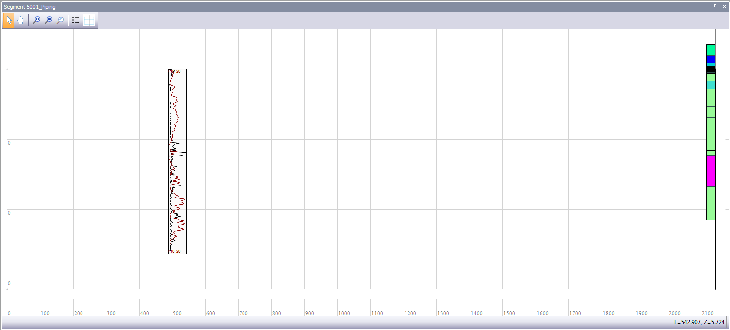

Image: Length Profile

Length Profile Toolbar

The length profile toolbar is shown at the top of the length profile panel and contains the following buttons:

- Selection Select geometry objects.
- Pan The pan view allows the user to pan along the geometry, by
dragging the mouse.
- Zoom to extents Zoom until all contents fit on screen. This zoom functionality shows the geometry with the most overview and the least detail.
- Zoom to extents and Zoom until all contents fit on screen (with the most overview and
reset aspect ratio the least detail) and makes scale of x and z directions equal.
- Zoom by rectangle Zoom to a rectangle, user defined by dragging the mouse.
- Options Show Editor options in the Properties panel.
- Add location for split Add location for splitting the soil segment into two segments.

Property Editors
The Properties panel is a context-dependent overview of object properties. Depending on the selected object in the data structure (for example a material or a profile), the corresponding properties are displayed. The Properties panel can show properties in a read-only (greyed out) or as an editable field. Of course, a user is only allowed to change the non-read-only properties. A property can also be displayed on the property editor as a table (similar to the tables described in 2.7.1 Data import). Individual columns of tables can be editable or read-only. The buttons in the table toolbar are enabled or disabled accordingly.
The object properties can be filtered according to the following filters in the application: the material table filter and the mechanism and parameters selection in the application toolbar. For the description of these filters, see 2.7.4.1.
The property editors help to implement a number of requirements from the functional design such as FD2.2.1.3 (Soil segments (stability) can be combined with surface line), FD2.3.4 (Changing chance of occurrence of the soil profiles), FD2.4.2 (Define aquifer layers per soil profile), FD2.4.4 (Define yield stresses per 2D soil profile) and FD2.5.2 (Define aquifer layers per soil profile)

Validation Messages

Validation messages is an overview of current status lines which each have the columns Severity, Message, Subject and Repair, for output log lines that refer to the real time data. These status lines are generated concurrently due to the continuously working data validation mechanism. The messages are also concurrently removed when issues are solved. If possible, a repair action is provided for the user (for example lower a variable, when its value is too high, to the maximum). This ensures that FD2.7 (Error handling) from the functional design is met.

Validation Messages Toolbar

The validation messages toolbar is shown at the top of the validation message panel and contains the following buttons:

- Fits columns Resizes all columns to fit all contents.
- Export Export the validation messages to file:
CSV Files (*.csv)
Text files (*.txt)
PDF Files (*.pdf)
Excel files (*.xls)
- Repair all Repair all validation results for which a repair option is available.

Log Messages

Log messages is an overview of log lines with the columns Severity, Subject and Message, for output log lines that refer to actions or events that occurred in the application (for example, output regarding an import action). This ensures that FD2.7 (Error handling) from the functional design is met.

Log Toolbar

The Log toolbar is shown at the top of the Log panel and contains the following buttons:

- Copy Copy to clipboard the contents of the log lines.
- Paste Paste the contents of the clipboard to log lines.
- Fits columns Resizes all columns to fit all contents.
- Edit Edit the currently selected field.
- Edit Unit Edit the unit for the used type.
- Export Export the validation messages to file:
CSV Files (*.csv)
Text files (*.txt)
PDF Files (*.pdf)
Excel files (*.xls)

View Menu

The View menu item allows the user to select/enable the following components of the user interface: Map, Viewer/Editor, Properties, Output, Messages and Tables. These components are each shown in a dockable panel for which the user can arrange the layout to his preference. The View menu item also provides a Reset option to return to the default layout of the user interface.

Tools Menu
The Tools menu item allows the user to select general Program Options.

Program Options

The Program Options allow the user to select what shows up as initial Project at Startup (a new project or the last project).

Help Menu
The Help menu item allows the user to select the About panel.

About

The About pane shows the following product info: product, version, company, copyright and license type. The About pane also has a Disclaimer button that displays the software license agreement as a popup.

Literature
- 1230088-026-DSC-0001 Functional Design D-Soil Model versie 03, aug. 2016, Irene van der Zwan.
- D-Soil Model - Technical Documentation. Code documentation generated from in-line code documentation (Doxygen).
- 1230088-026-DSC-0002 D-Soil Model Test Plan version 3.0, aug. 2016.
- 1230088-026-DSC-0006 D-Soil Model Test Report for version 1.0, version 1.0, aug. 2016.
- 1206004-004-GEO-0004 Geotechnics Design (Geotechnics Data Model).
- 1209430-000-DSC-0020 Deltares Framework, Rob Brinkman, 26 februari 2014, versie 1.0
- General requirements and design rules for WTI software https://repos.deltares.nl/repos/Ringtoets/trunk/doc/system/RTO design.doc
- Development procedure WTI Software https://repos.deltares.nl/repos/Ringtoets/trunk/doc/Procedures/software development procedure.doc

Data Model of UI Objects
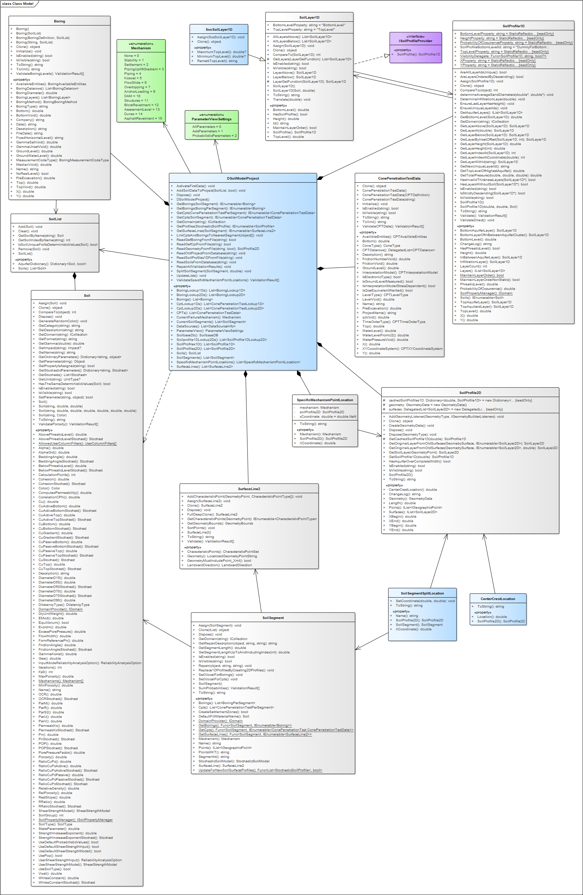

Overview requirements from Functional Design

In this overview, the use case paragraphs from the Functional Design are listed together with the location they are covered in this document.

Functional Design Paragraph | Location in document
2.1.1 | 2.7.1
2.1.2 | 2.7.5
2.1.3 | 2.7.4
2.1.4 | 2.7.6
2.1.5 | 2.7.3
2.1.6 | 2.7.3
2.1.7 | 2.7.3
2.2.1.1 | 2.7.6.1
2.2.1.2 | 2.7.6.2
2.2.1.3 | 2.4.2.7, 2.7.8
2.2.1.4 | 2.7.6.3
2.2.2 | 2.7.5.1
2.2.3.1 | 2.7.6.4
2.2.3.2 | 2.7.6.2
2.2.3.3 | 2.7.6.2
2.2.3.4 | 2.7.7
2.3.1 | 2.7.2, 2.7.5.1
2.3.2 | 2.7.5.1, 2.7.7
2.3.3 | 2.3, 2.7.4.2
2.3.4 | 2.3, 2.7.8
2.3.5 | 2.7.4.2, 2.7.6.2, 2.7.6.5
2.3.6 | 2.3, 2.7.4.2
2.3.7 | 2.7.4.2
2.3.8 | 2.7.4.2
2.4.1 | 2.7.3
2.4.2 | 2.4.2.5, 2.7.8
2.4.3 | 2.7.4.1, 2.7.4.2
2.4.4 | 2.4.2.2, 2.7.8
2.4.5 | 2.7.3, 2.7.4.2
2.5.1 | 2.7.6.2
2.5.2 | 2.4.2.5, 2.7.8
2.5.3 | 2.7.4.1, 2.7.4.2
2.5.4 | 2.7.3
2.6.1 | 2.7.3, 2.7.4.1, 2.7.4.2
2.6.2 | 2.7.2
2.6.3 | 2.7.4.2
2.7 | 2.3, 2.7.9, 2.7.10

A database management system (DBMS) is a computer software application that interacts with the user, other applications, and the database itself to capture and analyze data

