A short guide to FEWS-Risk/DAM-Live

Introduction
FEWS-Risk/DAMLive combines two applications in one FEWS systems. DAM-Live calculates the strength of dike cross-sections (safety factor) based on real-time data of water pressure from sensors installed in a dike body. FEWS-Risk calculates the probability of failure of dike cross-sections based on forecasted water level outside the dike and pre-calculated fragility curves.
The system has been developed for the pilot project of the Groningen dike north of Delfzijl. The FEWS configuration is in development and it can be found in the repository at this address:
https://repos.deltares.nl/repos/FEWS_DAMlive/FEWS-Risk_DAM
The material needs to be copied in a folder with the FEWS file systems (bin, jre8). Open the system with the .exe in the bin folder.

DAM-Live
As the system is a stand-alone, different workflow must be run to import data and perform calculations. The workflow page can be open with the button “handmatige taak”:
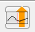
Under Workflow there are the possible actions for DAM-Live and FEWS-Risk (Fig. 1). The workflows of DAM-Live are “Import” (sensor data and water levels from DDSC), “Run DAMlive” (stability calculations), “Export” (export the results of the calculations) or “Run all” (run the three workflows).
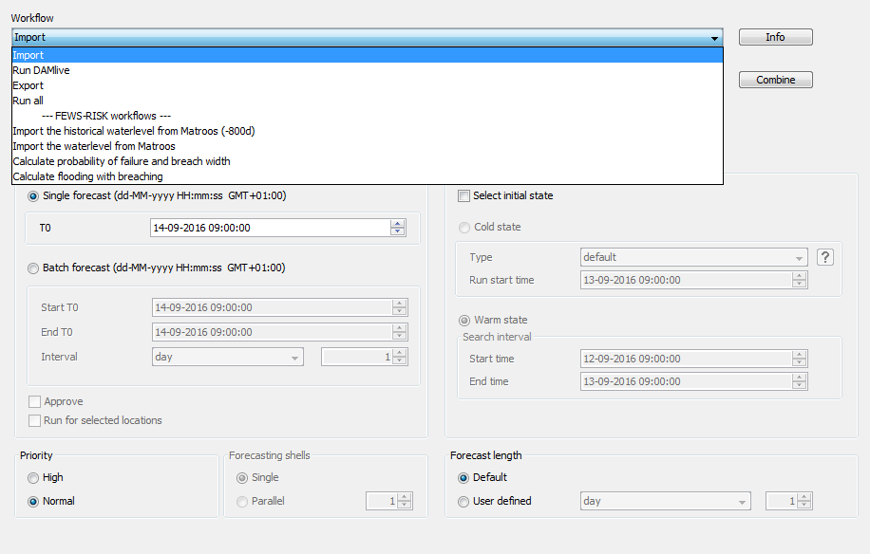
Fig.1
Select “Import” under Workflows and press Run. Select then the “Run DAMLive” workflow. Here you have to define for which times you want to perform the stability calculations. If you select Single forecast (in the window of Fig.1) the calculation will be perform for just one single defined time. Select “Batch forecast” and specify an initial and ending time for which you want to calculate the dike strength. Select underneath the interval in hours (data of sensors are imported every hour). Mind that a single calculation (for one specific time) may take few minutes, therefore it is better to define a range of the calculations (start and end time) that is not too wide.
After the workflow is completed it is possible to visualize the imported data in the graphs with the data display button:
Select one of the dike profiles on the left (from 28_0 to 38_0) and visualize data on the right: calculated safety factor, imported values of sensors and outside water level (Fig.2). Move in the graph with the mouse wheel or the arrows and zoom buttons:
The location of the profiles can be visualized in the map. You can select the map in the lower left corner of the window of Figure 2.
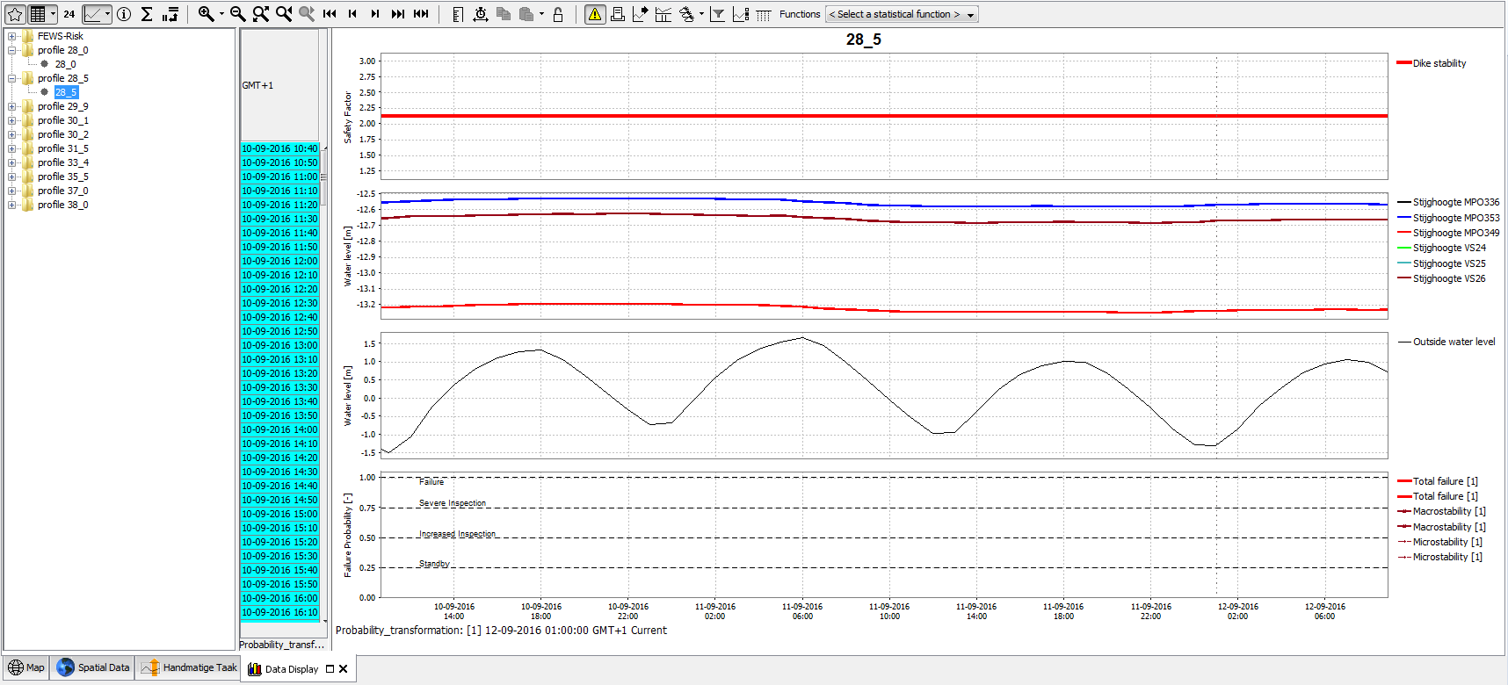
Fig.2

FEWS-Risk
For FEWS-Risk there are four workflows: Import the historical water levels (-800d), import the water levels, calculate the probability of failure and breach width, calculate flooding with breaching (chapter 4).
First, import the historical water levels (in the workflow window of Fig.1) selecting the workflow in the menu and pressing Run. This will import all the outside water levels of the past 800 days from the Matroos database. This process may take several minutes. Then run the workflow “import the water level from Matroos” to import the forecasted water level of the coming 48 hours from the Matroos database. At this point it is possible to run the workflow “calculate the probability of failure and breach width”. Once this process is ended, you can visualize the results in the Data Display window (Fig.3). Select the folder FEWS-Risk on the top left of the window. It is possible to visualize the total failure probability of all the dike profiles or the probability of the single mechanisms: wave impact, overflow, overtop, piping Sellmeijer, piping macro-stability, and piping micro-stability. The breach width shows if with the calculated probability and the defined breach threshold (see chapter 4) there will be a breach for one or more dike profiles.

Inundation model
The last workflow of FEWS-Risk calculates the flood development in case a breach is predicted for one or more profiles (see chapter 3).
The original value of failure probability at which a breach is predicted is 0.5. It is possible to change this value within FEWS with the FRC Modifier.
Open the modifier with the icon FRC Modifier:
It is possible to select and modify any property. The first property is the name section. The properties underneath refer to that section. Scroll down until the name section “frc_33_4” and modify the breach probability (“breach_prob”) of this section to a value of 0.05. In this case a breach will occur already for a failure probability of 5%.
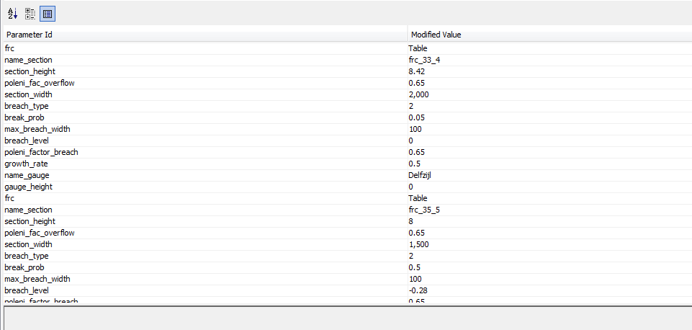
Fig.4

The duration of the inundation model can be modified in the file “Run_subgrid_breach.xml”, which is located in the folder Config\ModuleConfigFiles\fews_risk. Open the file with Altova and change the duration in minute as shown in figure 5 (for example 600 min = 10 hrs). In this way the model will run using data of the 10 hours after the current time and in case of breach during this time it will calculate the flooding.
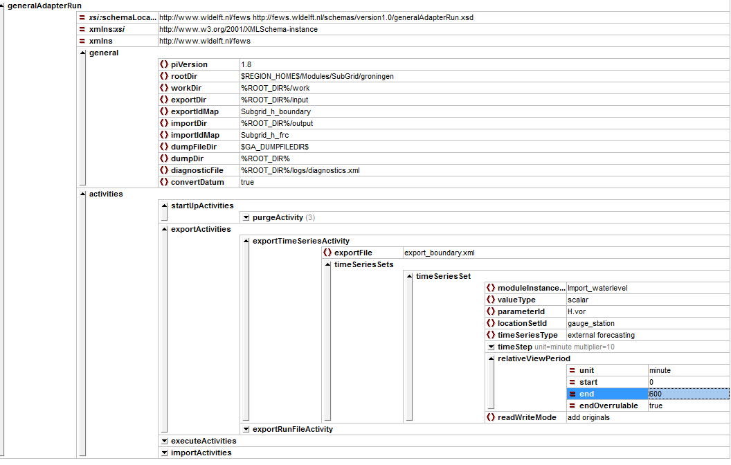
Fig.5
Important: before running the flooding model, the Current system time in FEWS must be set as 01:00 (the date is not important, for example 14-09-2016 01:00 (GMT+1)). You can do that clicking on “Current system time” at the bottom of the screen in FEWS.
Run now the workflow “Calculate flooding with breaching”.

